
JOB DESCRIPTION: Digital & Oral History Archivist

Reports to: Archive Manager

Fee: £250/day with 2% inflation in year 2 (1 day a week for Year 1, 1 day a month for Year 2) Full fee £16060

Hours: 1 day a week (7 hours) for year 1. 1 day a month (7 hours) in year 2.
Flexible/hybrid working is available. You can manage your hours flexibly but must be available to attend monthly sessions with Young Archivists groups (these take place on Tuesday evenings in Hackney). You will also need to be available to record oral histories within the London area & work closely with the archive manager and Hackney archives.

Contract: This is a 2 year freelance contract. 1 day a week in year 1. 1 day a month in year 2.
All appointments are subject to: 2 satisfactory references, Evidence of right to work in the UK & an Enhanced Level DBS check or willingness to undertake one.

Application Deadline: 10 am on 22nd June 2026
Please email completed application form to vicki@hackneyshed.org.uk by no later than 10 am on 22nd June 2026
Please save your application as your name & include your name and ‘DOHA26’ as the email subject when submitting.
Applications received after 10am on the deadline date will not be accepted.

Interview: Interviews will take place on Friday 3rd July in Hackney.

Start date: Contract will begin as soon as possible after interview

We particularly welcome applications from candidates who identify as disabled, neurodivergent, Black, Asian, from a minority ethnic background, LGBTQIA+ or from any under-represented socio-economic and educational backgrounds.

Access requirements for the application process
We want to make this application process as accessible as possible. If you do not find this application accessible for you, please get in touch with us at vicki@hackneyshed.org.uk and we can discuss alternatives. We would accept an application form in video or audio format.
In line with the Disability Confident scheme, we will ensure that disabled applicants that meet the minimum criteria for this position will be offered an interview. However, if we need to limit the total number of interviews offered we will offer a proportionate number of interviews to disabled applicants.
If you have any specific requirements including anything you might need should you get called for interview (e.g. interpreters, information in different formats etc.), or would like to discuss any aspect of the role in confidence, please contact vicki@hackneyshed.org.uk.
Please note, any information you provide around your access requirements will not form part of the shortlisting process.

About Hackney Shed:
Hackney Shed is an inclusive theatre company established in 2001 working with young people under 26, delivering workshops and creating performances.

Hackney Shed believes in a world in which young people of all experiences and contexts can come together and be creative. Our inclusive practice focuses on making all our activities accessible to a representative community of young people in Hackney and the surrounding boroughs, with a particular commitment to engaging young people with Special Educational Needs and Disabilities (SEND), neurodivergent individuals, and young people from diverse and low-income backgrounds. We pride ourselves on our ‘donate what you can’ policy which ensures accessibility with no financial barriers.


The Role:
We are seeking a passionate, organised and community-minded Digital and Oral History Archivist to lead on the digital heritage elements of Shedlight: Young Voices Shining a Light on 25 Years of Inclusive Practice. This is a 2 year National Lottery Heritage Fund project. This role is ideal for someone with experience in digital archiving, oral history collection and participatory heritage projects, who is looking to complement existing commitments while working creatively with young people in an inclusive arts setting.
Hackney Shed is an inclusive theatre company working with young people under 26 from across Hackney and surrounding boroughs, with a particular commitment to engaging disabled and neurodivergent young people, and those from low-income and under-represented backgrounds. Our two-year Shedlight project will preserve and celebrate 25 years of Hackney Shed’s work, grounding it in the wider context of inclusive practice with young people in Hackney.
Working closely with the Archive Manager, a group of Young Archivists, and project partners, you will lead on the creation of an accessible digital timeline and oversee the collection, recording and transcribing of oral histories that capture the voices and experiences of our community. A key part of the role will involve training and mentoring both staff and young people in archival and oral history practices, building the skills and confidence of the wider team to sustain the archive beyond the life of the project.
We are looking for someone with strong digital skills, including experience in digital preservation, cataloguing, and managing digital assets, excellent attention to detail, and a collaborative, inclusive approach. You will have experience handling archival materials and oral histories sensitively and ethically, ensuring outputs meet National Lottery Heritage Fund guidelines and prioritise accessibility and inclusion. This role will suit someone who enjoys balancing independent working with meaningful collaboration as part of a small, creative and values-driven team.
If you are passionate about preserving community stories, amplifying young voices, and making heritage accessible to all, we would love to hear from you.
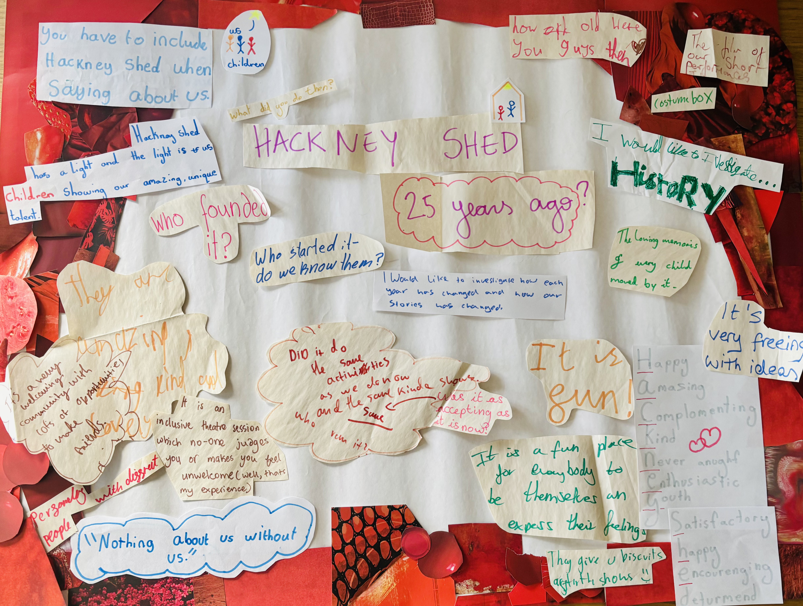

JOB DESCRIPTION: Digital and Oral History Archivist

Responsible to: Archive Manager

Pay rate: £250/day with 2% inflation in year 2 (1 day a week for Year 1, 1 day a month for Year 2) Full fee £16060

Key Responsibilities:

- To establish a digital preservation strategy that caters for long-term preservation of digital objects, both born-digital and assets created from digitisation.
- Research and recommend a digital preservation system suitable for our Digital Timeline.
- Work with Archive Manager and Young Archivists to determine items that will be part of our digital timeline.
- Create Digital Timeline which complies with National Lottery Heritage Fund’s digital guidelines.
- Provide recommendations on sustainable, low-cost digitisation methodologies
- Train Hackney Shed Team on how to maintain Digital Timeline
- Support Archive Manager in archival research
- Lead on training the young archivists and Archive Manager on collecting Oral Histories.
- Work with Archive Manager and Young Archivists to record 15 Oral Histories, recording 5 themselves and training the team to record the other 10.
- Transcribe all Oral Histories
- To work with and liaise with Partners, Hackney Archives, Chickenshed and our Archive Manager throughout the project within the context of our partnership agreements.
- To attend Monthly Young Archivist meetings when required.
- To prioritise access and inclusion across all aspects of the project, working with the wider Hackney Shed Team to ensure any additional access materials or support required is provided for the project.
- To work closely with staff and volunteers to meet Health & Safety Requirements.
- To be pro-active in ensuring adherence to the requirements for Safeguarding & Equal Opportunities policies. To constantly monitor and to actively promote good practice amongst all members, volunteers, parents/carers and the public.
- To adhere to the inclusive philosophy and equal opportunities policy of Hackney Shed during the provision of your services.
- The Digital and Oral Histories Archivist may be required for additional meetings or duties outside of work hours. These will be arranged as necessary, and terms and payment agreed on an individual basis if regular hours are exceeded.
- To communicate any issues regarding members, staff or safeguarding to the Artistic and Executive Director (Vicki) or board as appropriate. Please note that Vicki Hambley is the Designated Safeguarding Lead (DSL) for Hackney Shed.

Person Specification:

 | Essential | Desirable
- Qualifications And Experience:
- A relevant degree, professional qualification or proven experience in digital archiving and Oral Histories | *
- Knowledge & experience of significant laws, regulation and best practice including health & safety, child protection, risk management, GDPR and compliance. |  | *
- Relevant safeguarding certificate or willingness to undergo training | *
- Experience working with children and young people in an inclusive setting | *
- Abilities/Skills:
- Excellent IT skills and proven ability to create digital timelines | *
- Ability to maintain and nurture relationships, create opportunities and develop new relationships. | *
- Ability to handle a varied workload to tight and conflicting deadlines | *
- Disposition/Attitudes
- Ability to work co-operatively and productively with other members of a team, volunteers, parents, carers and stakeholders. | *
- A positive role model to members and stakeholders. | *
- A drive to work alone and in a team. | *
- Act sensitively to the needs of the situation as may be required. | *
- Ability to apply logic and judgement to practical situations to come to an effective, diplomatic or pragmatic solution. | *
- Training & Equal Opportunities.
- Willingness to keep professional knowledge and skills up to date. | *
- Commitment to equal opportunities and inclusive policy and practical awareness of how to implement it. | *

